**Presidential Popularity: A Matter of Sentiment?**

This paper is intended for a non-academic audience, as an exploratory article.

George Gallup was the forerunner of survey sampling techniques and creator of the statistical method of survey sampling for measuring public opinion. In the late 1930s, he focused his attention to politics, gauging the approval ratings of presidents and presidential candidates. (1)

Of course, many that predict opinions as well as individual poll results are imperfect and inaccurate. However, the aggregate approval rating is generally accepted by statisticians, as a statistically valid indicator of the comparative changes in the popular United States mood regarding a president.

In terms of predictions, to many the results of the 2016 presidential race were very surprising. Yet since the election, the majority of point in time polling suggests that the sitting president consistently polls around 30% to 40%, which is pretty low and flat compared to other presidents during their tenure (2).

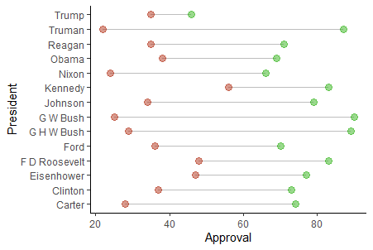

From my antidotal observations, today’s political administration seems to have a contentious and negative message that emphasizes conspiracy and deregulation over hope and progressive change.

The ranked approval ratings of presidents, along with my perceived negative overtone of the political environment today caused me to want to explore the following question:

**Does a president’s sentiment have an effect on their popularity?**

In order to explore the question posed above, I performed a text analysis of the State of the Union speeches to see if positive tone correlated with higher presidential approval.

I used the average Gallup approval ratings per president and compare them with the text analysis results of the State of the Union addresses per president. 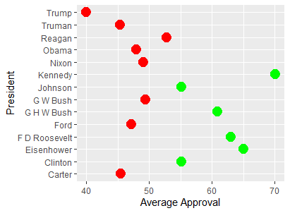 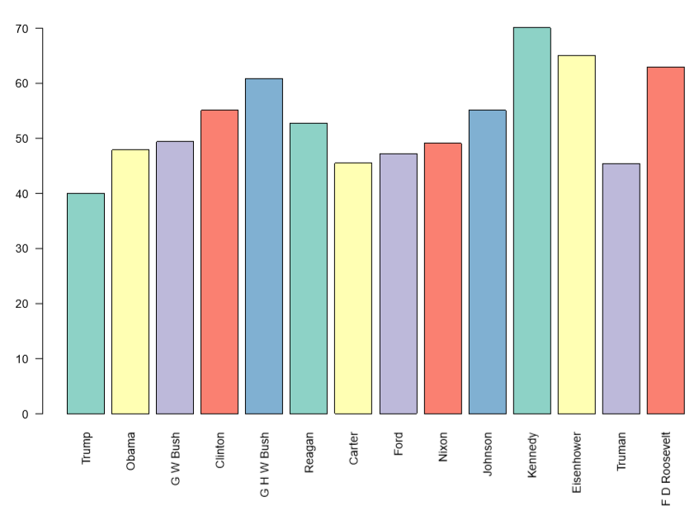

I started with a comparison of the **cumulative average approval** rating across the duration of each presidency with the **text analysis for all States of the Union** speeches together, **grouped per president**.

I used the “SOTU” package in R, which provides the raw text from each State of the Union for the text comparison. Given that point in time Gallup polls started in the late 1930s and the State of The Union corpus ends before 2017, my analysis and comparison will start with F.D. Roosevelt, the 32nd President, to President Barack Obama.1932 (3)

To complete the study, I employed text and sentiment analysis techniques as well as descriptive statistical analysis.

In my text analysis, I looked at percent of **positive vs. negative** sentiment per president.

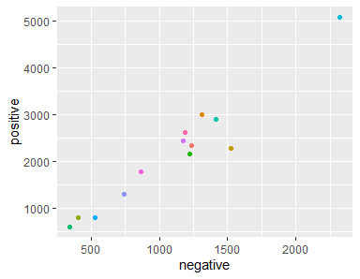

President negative positive sentiment

(Pos – Neg)

1 Barack Obama 1235 2344 1109

2 Dwight D. Eisenhower 1314 2995 1681

3 Franklin D. Roosevelt 1524 2296 772

4 George Bush 404 802 398

5 George W. Bush 1219 2156 937

6 Gerald R. Ford 347 615 268

7 Harry S Truman 1410 2897 1487

8 Jimmy Carter 2318 5077 2759

9 John F. Kennedy 531 816 285

10 Lyndon B. Johnson 744 1306 562

11 Richard M. Nixon 1179 2436 1257

12 Ronald Reagan 865 1781 916

13 William J. Clinton 1185 2612 1427

Then **compared** the variables **of positive and negative sentiments** with **popularity** in order to see if there are any **correlations**. 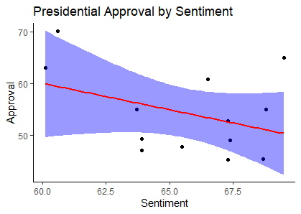

**Correlation**

* Correlation coefficient (Cor.coeff -0.3798176)
* t-test statistic value (t = 9.5426)
* Degrees of freedom (df= 11)
* p-value = 0.2005
* 95 percent confidence interval: -0.7697205 0.2164691

Avg % Avg% .fitted .se.fit .resid .hat .sigma .cooksd

positive sent Approval

1 69.5 65 64.1 1.37 5.38 0.221 2.38 0.620

2 60.1 63 64.4 1.21 -4.30 0.172 2.67 0.273

3 68.8 55.1 65.5 0.813 3.28 0.0776 2.87 0.0575

4 60.6 70.1 63.4 1.83 -2.80 0.393 2.84 0.489

5 63.9 47.2 66.6 1.10 -2.74 0.142 2.91 0.0851

6 63.9 49.4 66.3 0.960 -2.43 0.108 2.95 0.0471

Residuals:

|  |  |  |  |  |
| --- | --- | --- | --- | --- |
| Min | 1Q | Median | 3Q | Max |
| -4.3038 | -2.4321 | 0.4008 | 1.7985 | 5.3798 |

Coefficients:

Estimate Std. Error t value Pr(>|t|)

(Intercept) 73.3364 5.7162 12.830 5.83e-08 ***

AvgAppr -0.1418 0.1041 -1.362 0.201 ---

Signif. codes: 0 ‘***’ 0.001 ‘**’ 0.01 ‘*’ 0.05 ‘.’ 0.1 ‘ ’ 1

Residual standard error: 2.919 on 11 degrees of freedom

Multiple R-squared: 0.1443, Adjusted R-squared: 0.06647

F-statistic: 1.854 on 1 and 11 DF, p-value: 0.2005

**Explanation**

A correlation score of -0.3798176 shows a very week relationship between positive sentiment and greater approval.

Based on the p-value of 0.2005, there is weak evidence against the conjecture, so we would fail to reject the null hypothesis.

**References**

1. "George Gallup Biography". Encyclopedia of World Biography. <https://www.notablebiographies.com/Fi-Gi/Gallup-George.html>

2. <https://news.gallup.com/poll/116677/Presidential-Approval-Ratings-Gallup-Historical-Statistics-Trends.aspx>

3. <https://cran.r-project.org/web/packages/sotu/sotu.pdf>